1. Background
   1. Introduction

One of the most important sector for any country is its education system. It is where the path of development and progress lay its foundation stone. A high standard education system plays vital role for the future of the students. Meanwhile, within a couple of years after birth, almost all the children are sent to schools and in a country millions of students like us join schools and college for education. Hence, School fee payment system was developed to manage the student details which include the adding of new student, listing student records, modifying the student details, searching the particular student.

The term “School Fee Payment System” includes each and every details of every student admitted i.e. Name, Class, Phone number, Roll No. and many more and also assist for easy fee paying for the user and the payer. After completion of annual class, many students join new schools and some leave there schools. In addition to that students admit for new session make piles of line for paying their fees. It has been systematic till now. It gets much more difficult as the year passes to keep each and every record. But after this system has been implemented it will be a piece of cake for the users to maintain these problems smoothly and more efficiently.

* 1. Objective Of the project

The major objectives of School Fee Payment System are:-

* To keep track of each and every detail of student in the school.
* To make fee paying easier for the payer and receiver.
* To save time for the user to display and search for details of every student.
* Well protection for details of the student by password entry system.
* Simplifies the task and reduce the paper work.
  1. Advantages
* The system is convenient and flexible to use.
* It saves schools time, efforts, money and resources.
* Password protected.
  1. Limitation
* The user has to manually keep updating the information by entering the details in the system.
* Chance of mistake.
* Can’t of back in menu without entering data.
* The user can not delete records.
  1. Future Implementation for the project
* Making the Software as a online application such that the program can be used anywhere and anytime.
* Adding new payment medium like online transfer
* We can make software automated.
* We can add delete option to delete unnecessary records.
* We can also make the project more attractive.
* The number of people handling the software can be made unlimited in future.
  1. Process in the project Use

This software is made to be used by Accountant, exam department and Students themselves. The user cannot use some feature of software like Adding records, Modify/Edit records and Payment unless he/she provides the password. But user can use some features of software like list records and search records without password.

* 1. Introduction to software/language used

C is the programming language developed at AT & T’s Bell Laboratories of USA in 1970s. It was developed by Dennis Ritchie. C is Structure programming language or Procedure oriented programming which use top down development process. It stands in between high level language and low level language. That is why it is often called a Middle level language. It is designed to have both: relatively good programming efficiency (as compared to machine oriented language) and relatively good machine efficiency. C seems so popular because it is reliable, simple and easy to use.

1. Hardware & Software Requirements
   1. Hardware Requirements

Processor : P-3 or Higher

Ram : 256 MB or more

Hard Disk : 1 GB or more

Monitor : color monitor

* 1. Software Requirements

Operating System : MS Windows XP, 7, 8, or 10

Compiler : C language

1. PROBLEM FACED

The main problem faced while developing this software are as follows:

* Complexity on coding and designing.
* As we were not familiar with the Graphics concepts in c language, at first it was very difficult for us to understand Graphics working style and different features used in it such as its keywords/function.
* Difficulty in using and understanding the different functions.
* Due to lack of different feature and tools in our software or programming language we were unable to make our project effective and attractive.
* Difficulty in debugging.

1. SYSTEM DESIGN
   1. Algorithm:

The system consists of different sets of algorithms.

1. : Start
2. :Determine all variable
3. : Program asks for options as Add Records, List Records, Edit Records, Fee payment, Search Records, Exit Program. On the main menu
4. : For condition 1(Add record):
5. Asks for password.
6. If right password is entered
   1. Program asked for student information like class, roll no., name, amount, etc.
   2. Then given data is save in file.

Else go to main menu.

1. : For condition 2(List records):
2. Ask for class of student
3. If the class exit in record, Display record.

Else go to main menu.

1. : for condition 3(Edit records):
2. Ask for password,
3. If right password is entered,
   1. Again ask for class and roll no. of student,
   2. If class and roll no. found , display current data of student and ask for new data

Else go to main menu.

Else go to main menu.

1. : for condition 4(Payment):
2. Ask for password,
3. If right password is entered,
   1. Again ask for class and roll no. of student,
   2. If class and roll no. found , ask for amount of payment and deduct with total amount

Else go to main menu.

Else go to main menu.

1. : for condition 5(Search records):
2. Ask for password,
3. If right password is entered,
   1. Again ask for class and roll no. of student,
   2. If class and roll no. found , Display record

Else go to main menu.

Else go to main menu

1. : And for the last Condition of the first menu the program exists. It actually ends the program using exit(0) making termination of program
2. Stop

**Although the steps are taken as simplest way there are further deeper algorithms for the separate functions shown in the Options.**

|  |  |
| --- | --- |
| C | Class |
| S.C | Class saved in file |
| R | Roll number |
| S.R | Roll number saved in file |

|  |  |
| --- | --- |
| T | True |
| F | False |
| P | Password |
| x | Variable |

* 1. Flowchart

If C=S.C

If P=X

If P=X

If P=X

Add records

List all records

IfC=S.C& R=S.R

Input C & R

List search records

IfC=S.C& R=S.R

IfC=S.C& R=S.R

Input C & R

Edit records

Fee Payment

Declaration of variable

Display Menu

Switch

Case 1

Case 6

Default

Input P

Case 2

Input C

Case 3

Input P

Case 4

Input P

Case 5

Input C & R

**T**

**T**

**T**

**T**

**F**

**T**

**T**

**F**

**F**

**F**

**F**

**F**

**F**

**T**

1. Source code

#include<stdio.h>

#include<conio.h>

#include<stdlib.h>

#include<string.h>

#include<graphics.h>

void menu();

void add();

void list();

void edit();

void payment();

void search();

void screen();

void info();

void data();

void password();

void notfound();

void null();

void title(char *);

struct std

{ int cls;

float amt;

char r[5],pn[20],n[25];

}s;

long int size=sizeof(s);

int n=0,i=0,cls,gd=DETECT,gm;

char r[5],c,p[10],x[10]="kist";

FILE *f;

void main()

{ initgraph(&gd,&gm,"C:\\TC\\BGI");

screen();

settextstyle(7,0,2);

outtextxy(160,190,"SCHOOL FEE PAYMENT SYSTEM");

outtextxy(180,240," By ASHISH BHASIMA");

outtextxy(180,270," RUKESH BASUKALA");

getch();

menu();

}

void menu()

{ char t[]="MAIN MENU";

while(1)

{screen();

title(t);

delay(500);

outtextxy(130,145,"1) Adding new records");

outtextxy(130,170,"2) List of records");

outtextxy(130,195,"3) Modifying records");

outtextxy(130,220,"4) Payment");

outtextxy(130,245,"5) Searching records");

outtextxy(130,270,"6) Exit.");

delay(500); outtextxy(130,320,"Enter your choice(1-6): ");

c=getche();

screen();

switch(c)

{ case '1':

password();

add();

break;

case '2':

list();

break;

case '3':

password();

edit();

break;

case '4':

password();

payment();

break;

case '5':

search();

break;

case '6':

exit(0);

break;

default:

screen();

setcolor(12);

outtextxy(250,220," INVALID choice");

outtextxy(250,240,"PLEASE TRY AGAILN");

getch();

menu();

}

outtextxy(180,370," ***Enter any key to goto menu***");

getch();

}

}

void add()

{ char t[]="ADD RECORDS";

f=fopen("c:/student.txt","a+");

if(f==NULL)

null();

screen();

title(t);

gotoxy(20,13); printf("Class:");

scanf("%d",&s.cls);

gotoxy(20,14); printf("Roll no.:");

scanf("%s",&s.r);

gotoxy(20,15); printf("Name:");

scanf("%s",&s.n);

gotoxy(20,16); printf("Phone number:");

scanf("%s",&s.pn);

gotoxy(20,17); printf("Total amount:");

scanf("%f",&s.amt);

fwrite(&s,sizeof(s),1,f);

fclose(f);

outtextxy(180,350,"Enter y if you want to add another record:");

c=getche();

if(c=='y'|| c=='Y')

add();

fclose(f);

}

void list()

{int n=0;

char a[20],t[]="LIST RECORDS";

f=fopen("c:/student.txt","r+");

screen();

if(f==NULL)

null();

title(t);

gotoxy(20,15); printf("Which Class record do you want to see:");

scanf("%d",&cls);

screen();

title(t);

outtextxy(90,100,"Class");

outtextxy(145,100,"Roll no.");

outtextxy(225,100,"Name");

outtextxy(345,100,"Phone number");

outtextxy(470,100,"Totl Amount");

setcolor(15); rectangle(70,110,580,115);

setcolor(10);

i=20;

while(fread(&s,sizeof(s),1,f)==1)

{ if(s.cls==cls)

{if(i>250)

{outtextxy(180,370,"***Enter any key to continue***");

getch();

screen();

title(t);

outtextxy(90,100,"Class");

outtextxy(145,100,"Roll no.");

outtextxy(225,100,"Name");

outtextxy(345,100,"Phone number");

outtextxy(470,100,"Totl Amount");

setcolor(15); rectangle(70,110,580,115);

setcolor(10);

i=20;

}

sprintf(a,"%d",s.cls); //accept int value convert into string

delay(500); outtextxy(90,110+i,a);

outtextxy(145,110+i,s.r);

outtextxy(225,110+i,s.n);

outtextxy(345,110+i,s.pn);

sprintf(a,"%.2f",s.amt);

outtextxy(470,110+i,a);

i=i+20;

n=1;

}

}

if(n==0)

notfound();

fclose(f);

}

void edit()

{ int n=0;

char t[]="EDIT RECORDS";

f=fopen("c:/student.txt","r+");

if(f==NULL)

null();

title(t);

info();

title(t);

while(fread(&s,sizeof(s),1,f)==1)

{if(strcmp(s.r,r)==0 && s.cls==cls)

{ gotoxy(20,8); printf("Old Data:");

data();

setcolor(15); rectangle(70,245,580,250);

gotoxy(20,17); printf("Enter New Data:");

gotoxy(20,18); printf("Class:");

scanf("%d",&s.cls);

gotoxy(20,19); printf("Roll number:");

scanf("%s",&s.r);

gotoxy(20,20); printf("Name:");

scanf("%s",&s.n);

gotoxy(20,21); printf("Phone number:");

scanf("%s",&s.pn);

gotoxy(20,22); printf("Total amount:");

scanf("%f",&s.amt);

fseek(f,-size,SEEK_CUR);

fwrite(&s,sizeof(s),1,f);

n=1;

}

}

if(n==0)

notfound();

fclose(f);

}

void payment()

{ int n=0;

float amt;

char t[]="PAYMENT";

f=fopen("c:/student.txt","r+");

if(f==NULL)

null();

title(t);

info();

title(t);

while(fread(&s,sizeof(s),1,f)==1)

{if(strcmp(s.r,r)==0 && s.cls==cls)

{ gotoxy(20,8); printf("Record:");

data();

setcolor(15); rectangle(70,245,580,250);

gotoxy(20,17); printf("Enter payment amount:");

scanf("%f",&amt);

s.amt=s.amt-amt;

rectangle(70,295,580,300);

gotoxy(20,20); printf("Remaining amount:%.2f",s.amt);

fseek(f,-size,SEEK_CUR);

fwrite(&s,sizeof(s),1,f);

n=1;

}

}

if(n==0)

notfound();

fclose(f);

}

void search()

{ int n=0;

char t[]="SEARCH RECORDS";

f=fopen("c:/student.txt","r+");

if(f==NULL)

null();

title(t);

info();

title(t);

while(fread(&s,sizeof(s),1,f)==1)

{ if(strcmp(s.r,r)==0 && s.cls==cls)

{ gotoxy(20,8); printf("Student record:");

data();

n=1;

}

}

if(n==0)

notfound();

fclose(f);

}

void screen()

{ cleardevice();

setcolor(15);

setfillstyle(6,15);

rectangle(65,80,585,385);

rectangle(70,85,580,380);

floodfill(67,200,15);

setcolor(10);

settextstyle(12,0,1);

}

void info()

{gotoxy(25,12); printf("Enter class of student:");

scanf("%d",&cls);

gotoxy(25,15); printf("Enter Roll no. of student:");

scanf("%s",&r);

screen();

}

void data()

{ gotoxy(20,10);

printf("Class: %d",s.cls);

gotoxy(20,11);

printf("Roll number: %s",s.r);

gotoxy(20,12);

printf("Name: %s",s.n);

gotoxy(20,13);

printf("Phone number: %s",s.pn);

gotoxy(20,14);

printf("Current amount: Rs %.2f",s.amt);

}

void password()

{ screen();

outtextxy(250,350,"Press Esc to goto menu");

gotoxy(25,15);

printf("enter password:");

for(i=0;i<10;i++)

{p[i]=getch();

n=p[i];

if(n==13) //13 is ASCII value of Enter

break; //to break loop when press Enter

if(n==27) //27 is ASCII value of Esc

menu(); //to go back to menu when press Esc

else

printf("*");

}

p[i]='\0'; //end the string

screen();

if(strcmp(p,x)!=0)

{ screen();

setcolor(12);

outtextxy(240,220," ***Wrong password***");

outtextxy(180,370," ***Enter any key to goto menu***");

getch();

menu();

}

}

void notfound()

{ screen();

setcolor(12);

outtextxy(240,220," !!!record not found!!!");

}

void null()

{ screen();

setcolor(12);

outtextxy(240,220," !!!FILE IS EMPTY!!!");

outtextxy(180,370," ***Enter any key to goto menu***");

getch();

menu();

}

void title(char *t)

{ setcolor(14);

settextstyle(1,0,2);

outtextxy(260,50,t);

setcolor(10);

settextstyle(12,0,1);

}

1. Screen short
   1. First screen

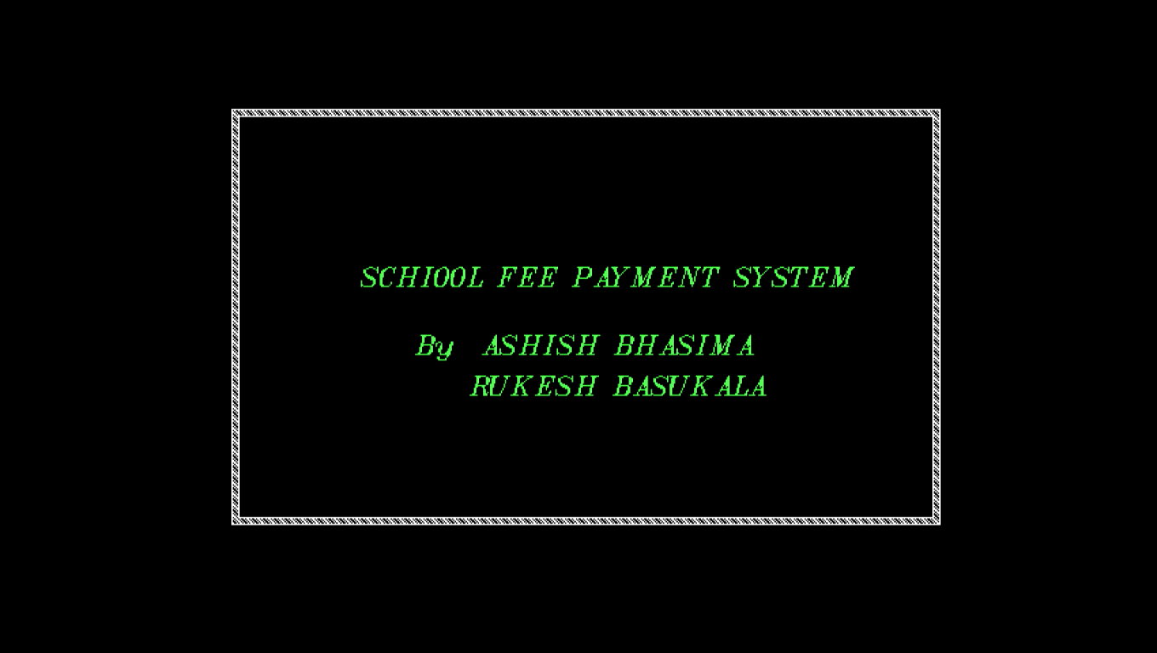

* 1. Main menu

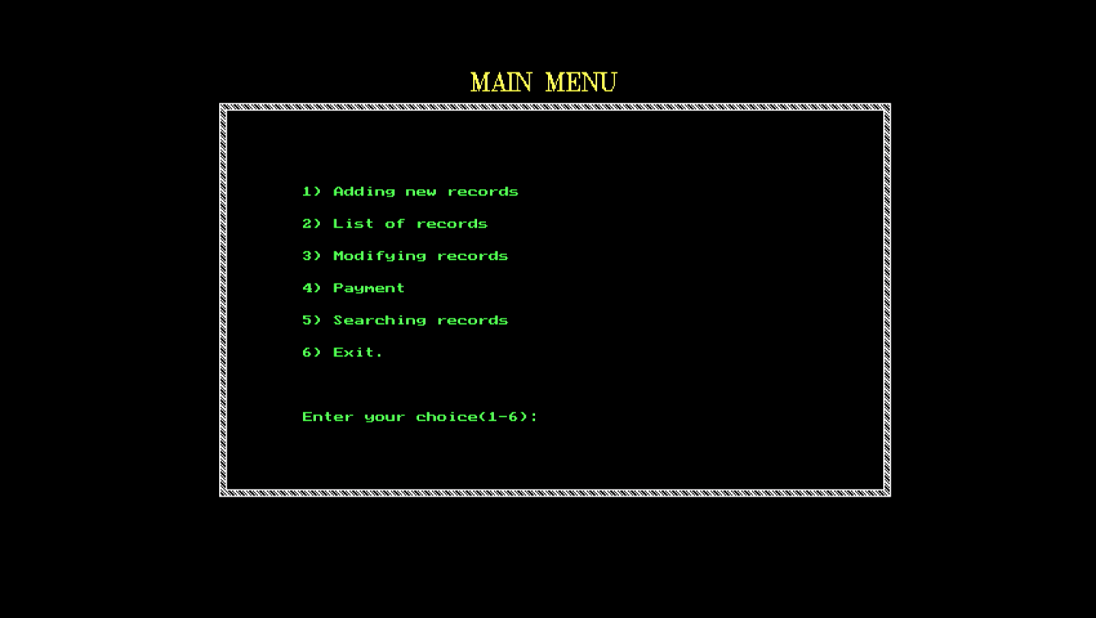

* 1. Password Screen

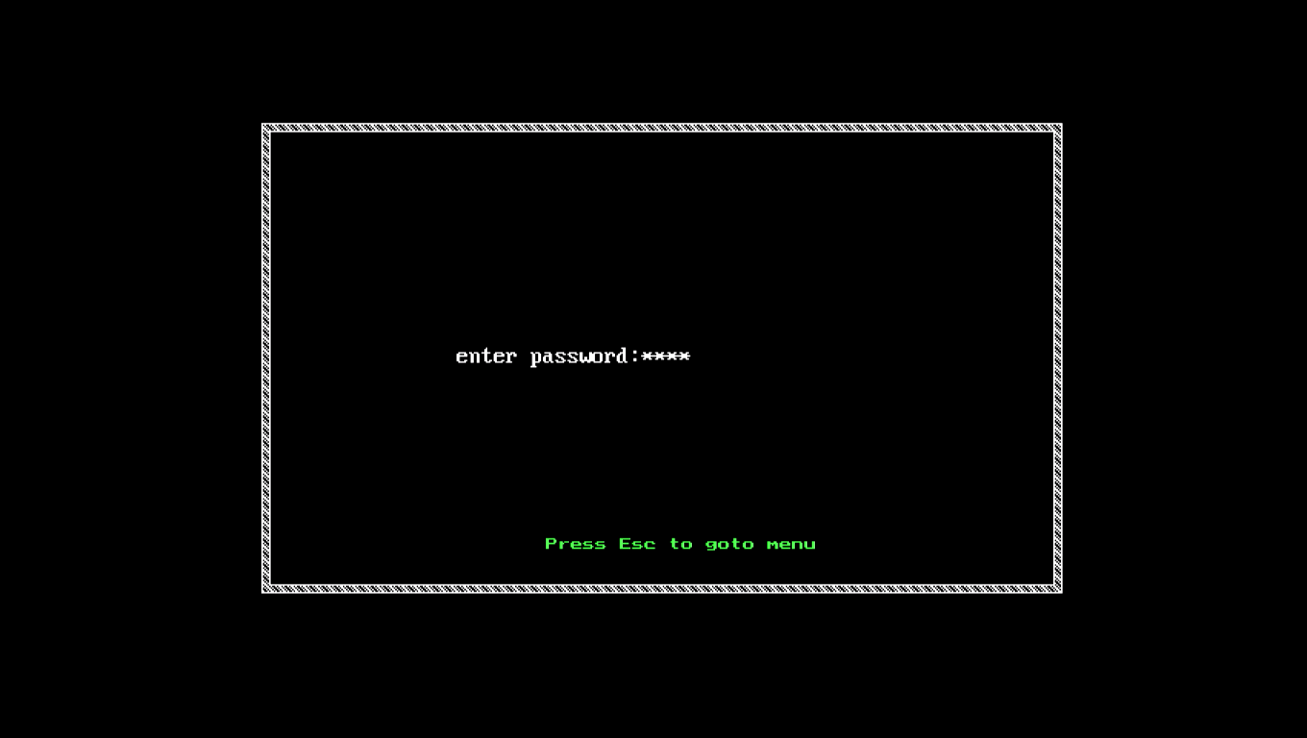

* 1. Student information

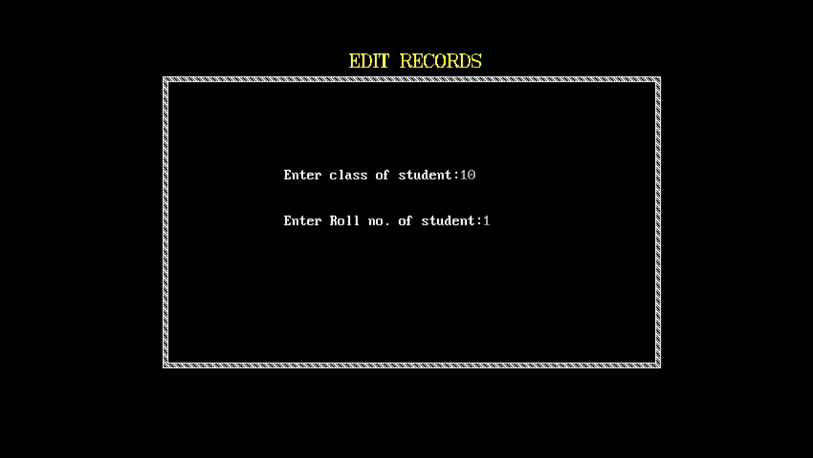

* 1. Add records

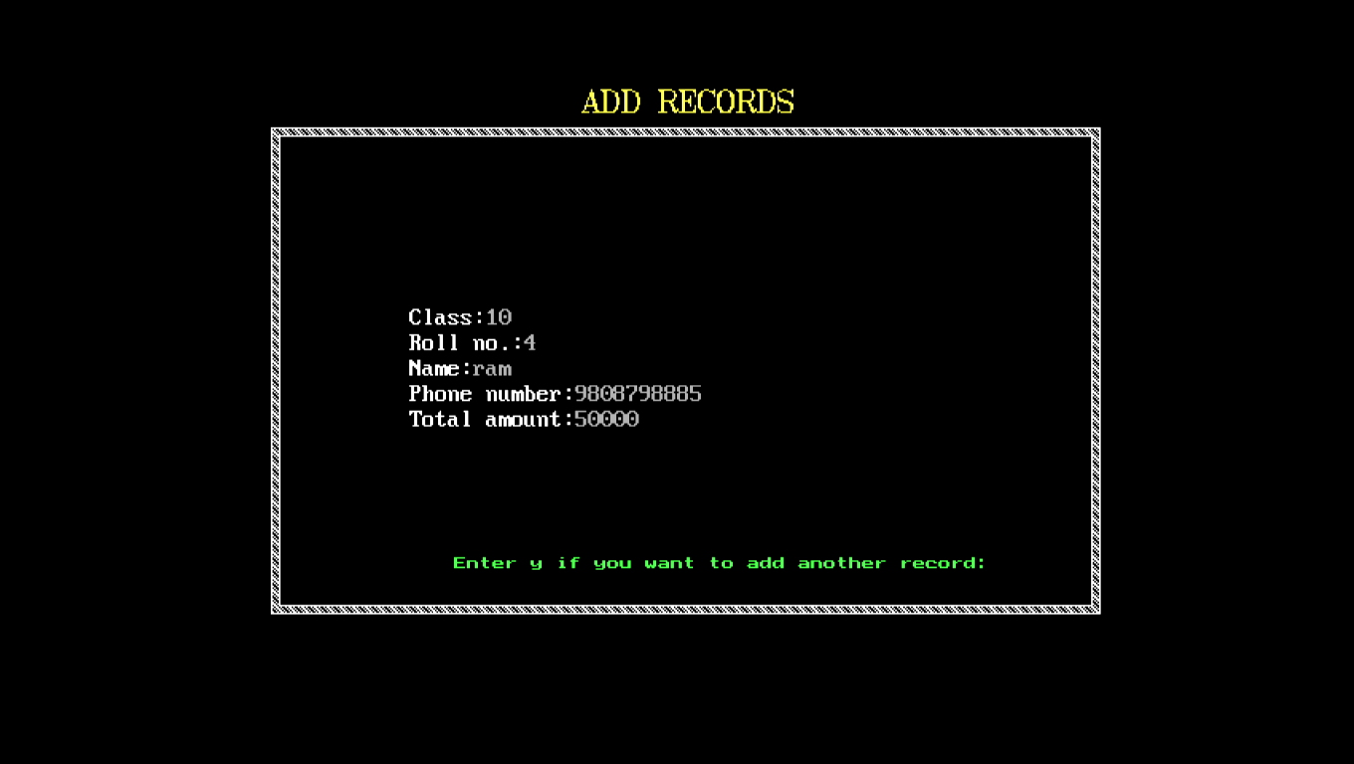

* 1. List records

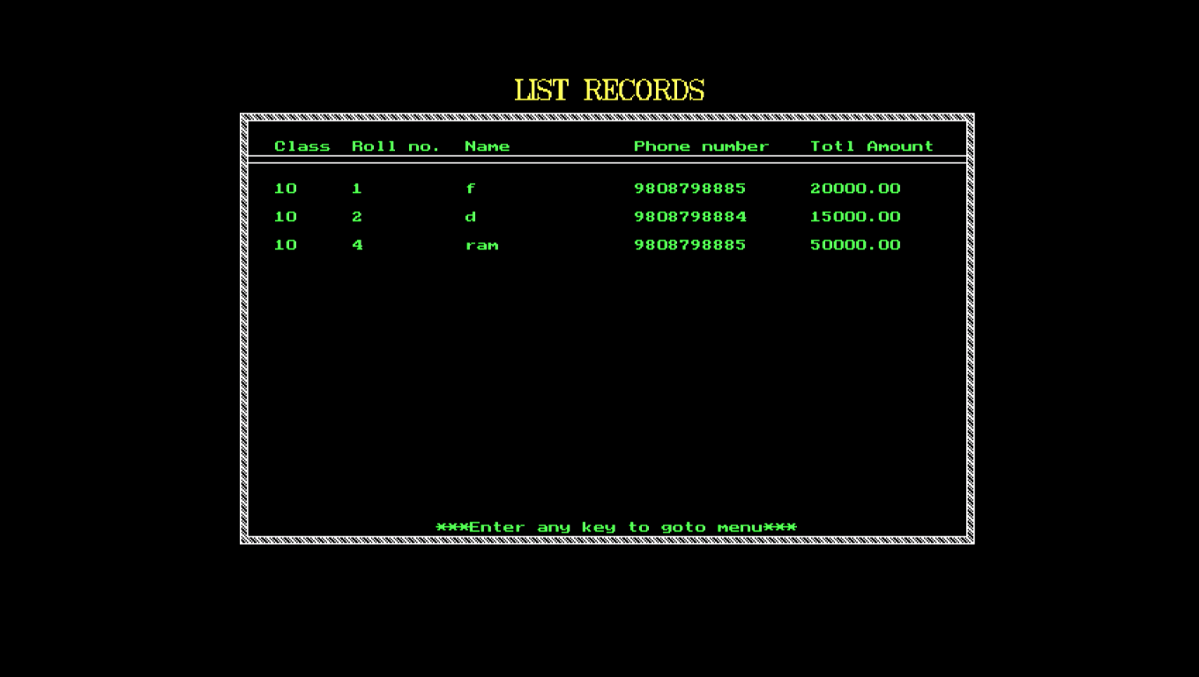

* 1. Edit records

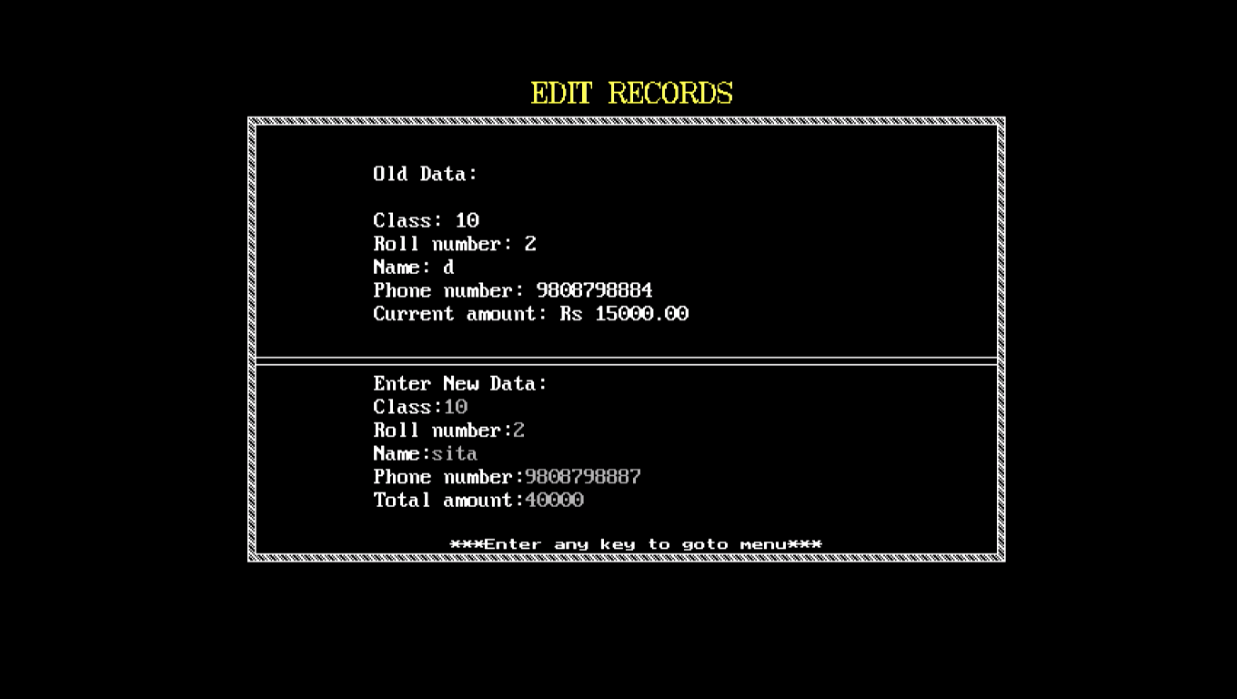

* 1. Payment screen

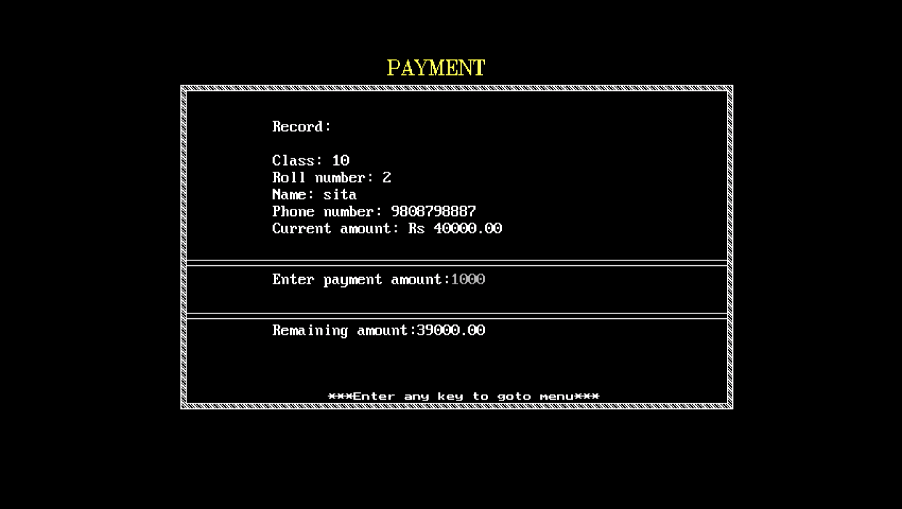

* 1. Search records

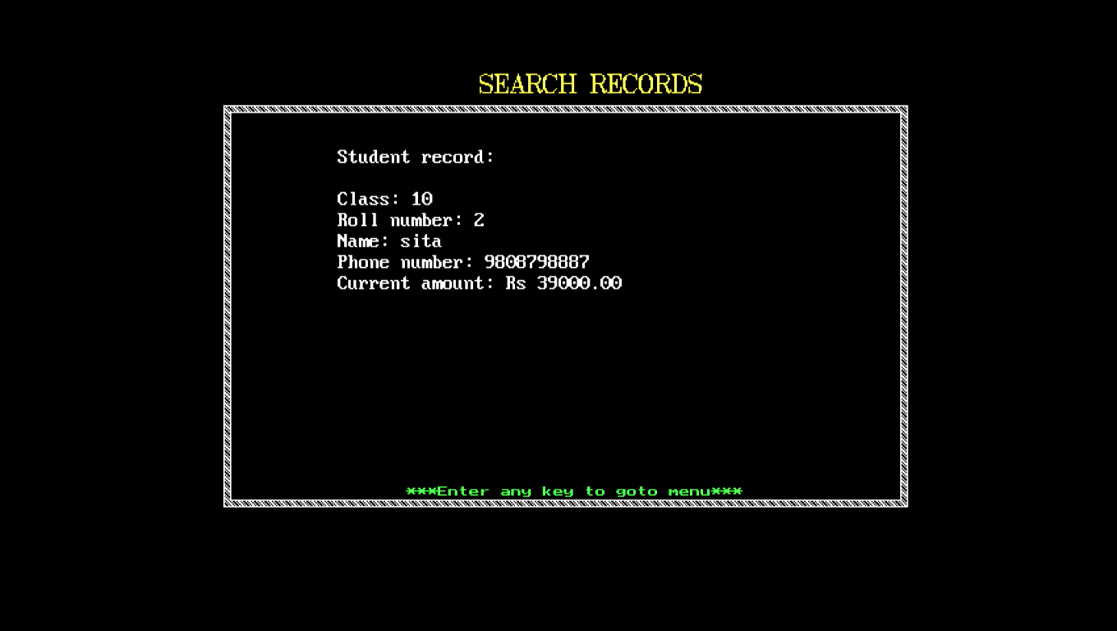

1. CONCLUSION

This project has been great opportunity for us to learn about C programming or basic of programming. Also we have learned much more about programming which we have not understand during our study. Which will help us to improve our programming skill by making foundation of programming. This will help us to work on our future and also for future more project that come during our studies.

8. BIBLOGRAPHY

1. Computer Essentials - Asmita's (3rd edition 2015)

* Prachandra Ram Shrestha
* Sudeep Manandhar
* Purna Rokka
* Roshan Bhusal
* Ridip Khanal

2. https://www.slideshare.net/PriyankaYadav158/employee-payroll-management-systempriyanka-yadav-project-using-c-64805029